Laporan Quiz 2 - Basis Data
Nama: Abryan Yoga Pratama

Soal
- 1. Total jumlah seluruh penjualan (total/revenue).
- 2. Total quantity seluruh produk yang terjual.
- 3. Total quantity dan total revenue untuk setiap kode produk.
- 4. Rata-rata total belanja per kode pelanggan.
- 5. Tambahkan kategori revenue: High (>300K), Medium (100K–300K), Low (<100K).

Query SQL

1.Total Revenue

SELECT SUM(qty * harga) AS total_revenue
FROM ms_transaksi;
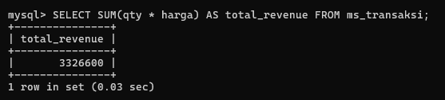

2.Total Quantity

SELECT SUM(qty) AS total_quantity
FROM ms_transaksi;

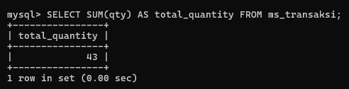

3.Revenue per Produk
SELECT kode_produk, SUM(qty) AS total_quantity,
SUM(qty*harga) AS total_revenue
FROM ms_transaksi
GROUP BY kode_produk;

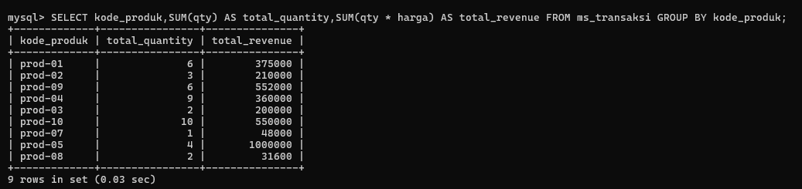

4.Rata-rata Belanja

SELECT kode_pelanggan, AVG(qty*harga) AS rata_rata_belanja
FROM ms_transaksi
GROUP BY kode_pelanggan;

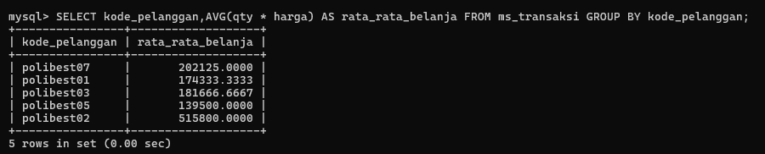

5. Kategori Revenue
SELECT kode_produk,
SUM(qty) AS total_quantity,
SUM(qty*harga) AS total_revenue,
CASE WHEN SUM(qty*harga)>300000 THEN 'High'
WHEN SUM(qty*harga) BETWEEN 100000 AND 300000 THEN 'Medium'
ELSE 'Low' END AS kategori
FROM ms_transaksi
GROUP BY kode_produk;

